CS 148 Final Project Report

# A Christmas Snow Globe

## By Boyu Liu, Rui Yan, Tianci WANG

# Problem Statement

Our target is to construct, in real time, a Christmas Snow Globe, mainly consisting of a glass ball, a system of drifting snowflakes, a base propping up the glass globe, a desk plain supporting the base and a sky background. Below is a prototype of our project.

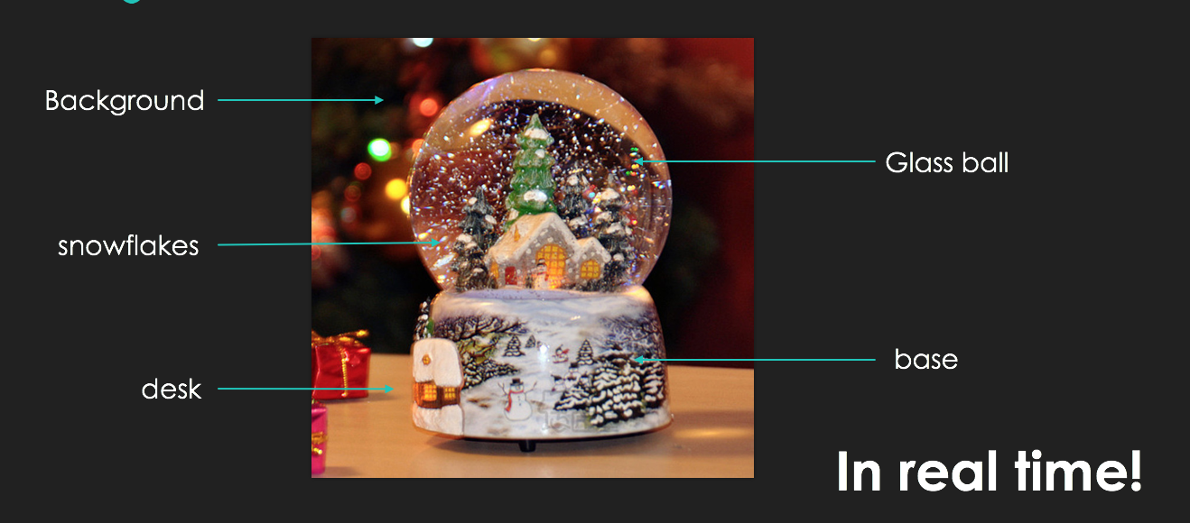

To be more specific, our background is expected to display 3D environment characteristics, allowing users to navigate within. Our glass ball is expected to possess optical properties of glass, reflecting and refracting lights. The system of snowflakes will simulate drifting, melting and regenerating and spraying. And above features will be implemented in real time, providing controls of snowflake mode and choice of perspectives.

# Overview of Steps

1. Setup skybox
2. Use small triangles to build a huge sphere
3. Add refraction and reflection to the sphere
4. Draw snowflake and simulation different mode of movement
5. Set base

# Detailed Progression

1. Setup skybox

(details)

1. Use small triangles to build a huge sphere

(details)

1. Add refraction and reflection to the sphere

For milestone, we simply implement static environment mapping and map the skybox to the snow globe. In this manner the distance between the viewing position and the sight incident position doesn’t change the reflection and refraction we get looking at the ball (see pictures 3.c.1). The visual effect is similar to looking at a painted ball with the image of sky on it.

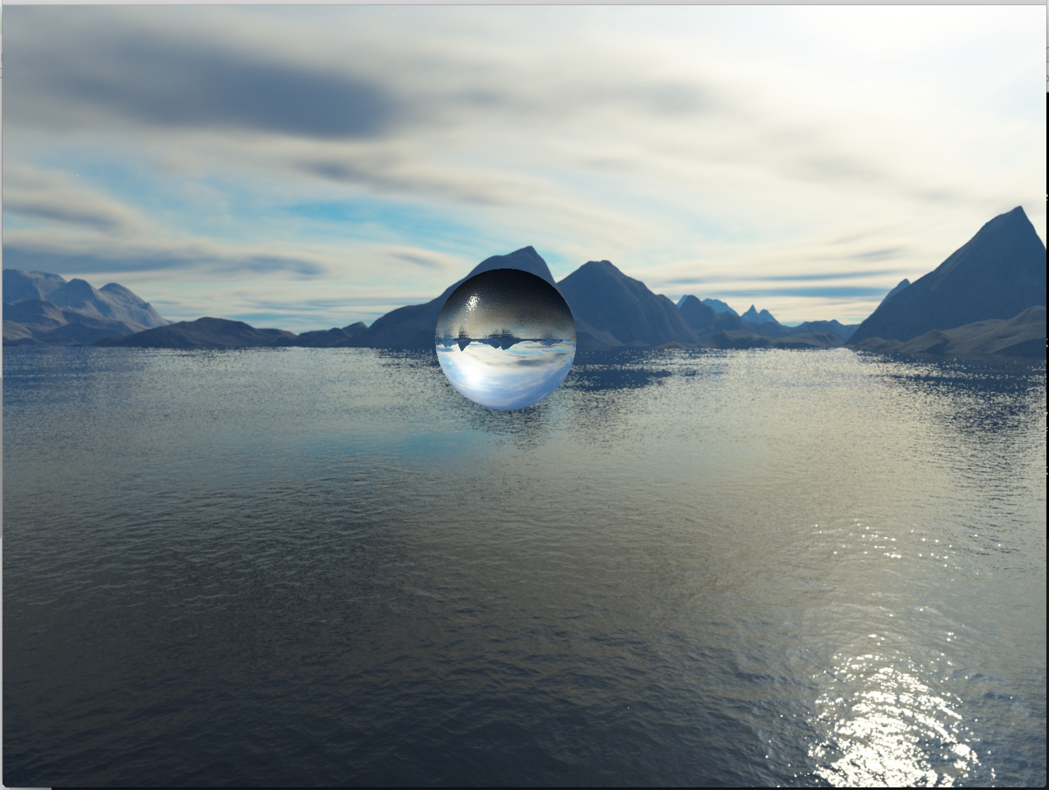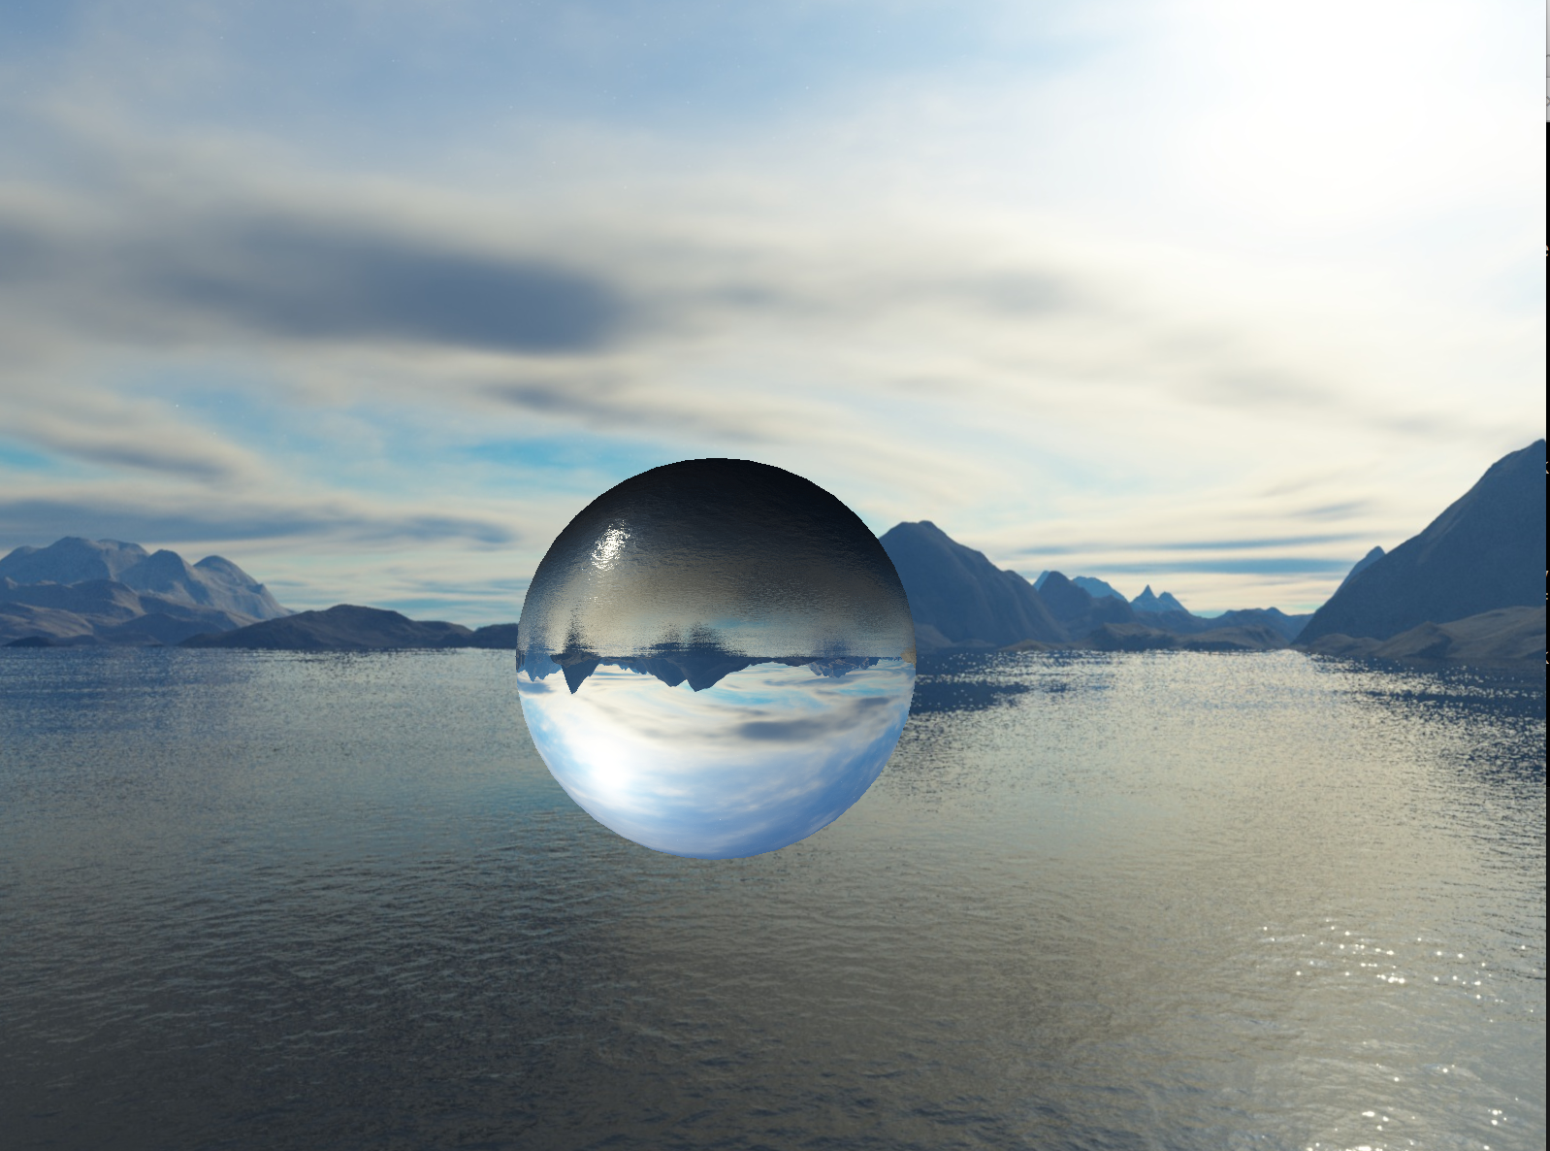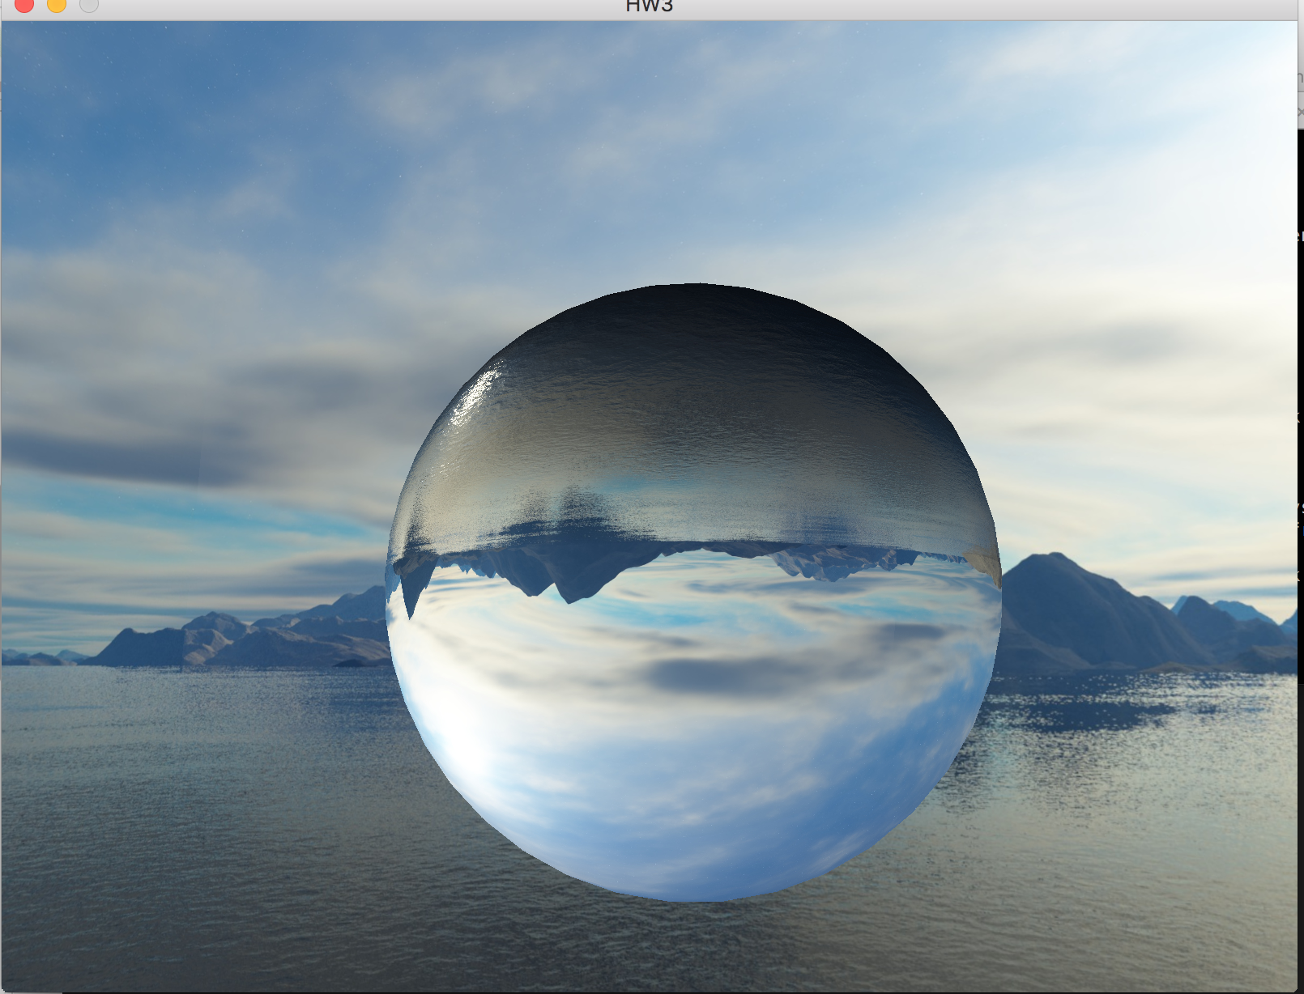

Decreasing distance from camera to globe

pictures 3.c.1

To obtain glass optical characteristics, we’ve done some improvements.

Firstly, we take the relative position between the camera and the incident point into account when performing shading. This approach delivers better user experience when one explores the globe from different aspects.

Secondly, we simulate two physics phenomenon, namely Fresnel Reflection and Chromatic Aberration. Fresnel Reflection is the reflection of light predicted by Fresnel equations, which describe the behaviors of light when moving between media of different refractive indices. In actual implementation, we adopt Schlick’s approximation, which gives us an approximate value of the specular reflection coefficient R (see pictures 3.c.2). Chromatic aberration is a dispersion effect, where lights of different colors correspond to various refractive indices for the lenses (,in this case, the globe). To implement this, we simply assign different refractive indices for Red, Green and Blue, the calculate the refractive color separately for these three. The resulting refraction is the combination of the three parts. (see pictures 3.c.3)

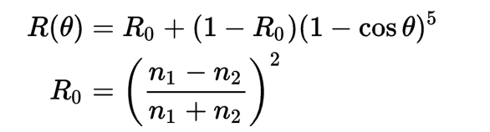

Schlick’s Approximation

pictures 3.c.2

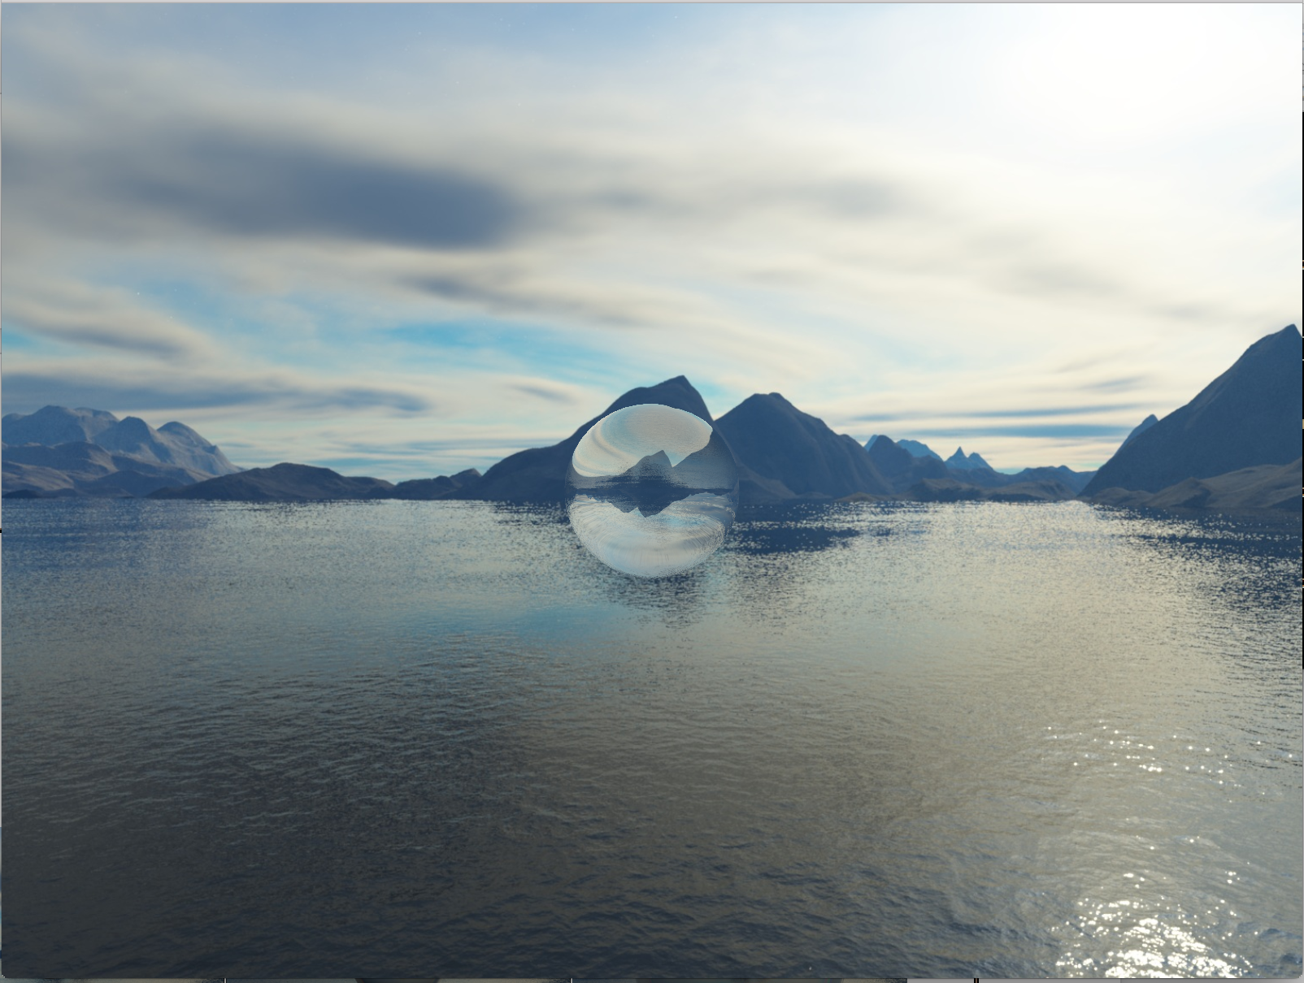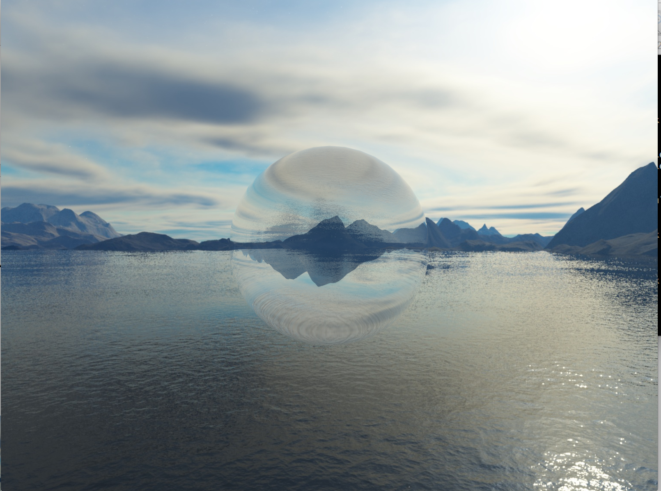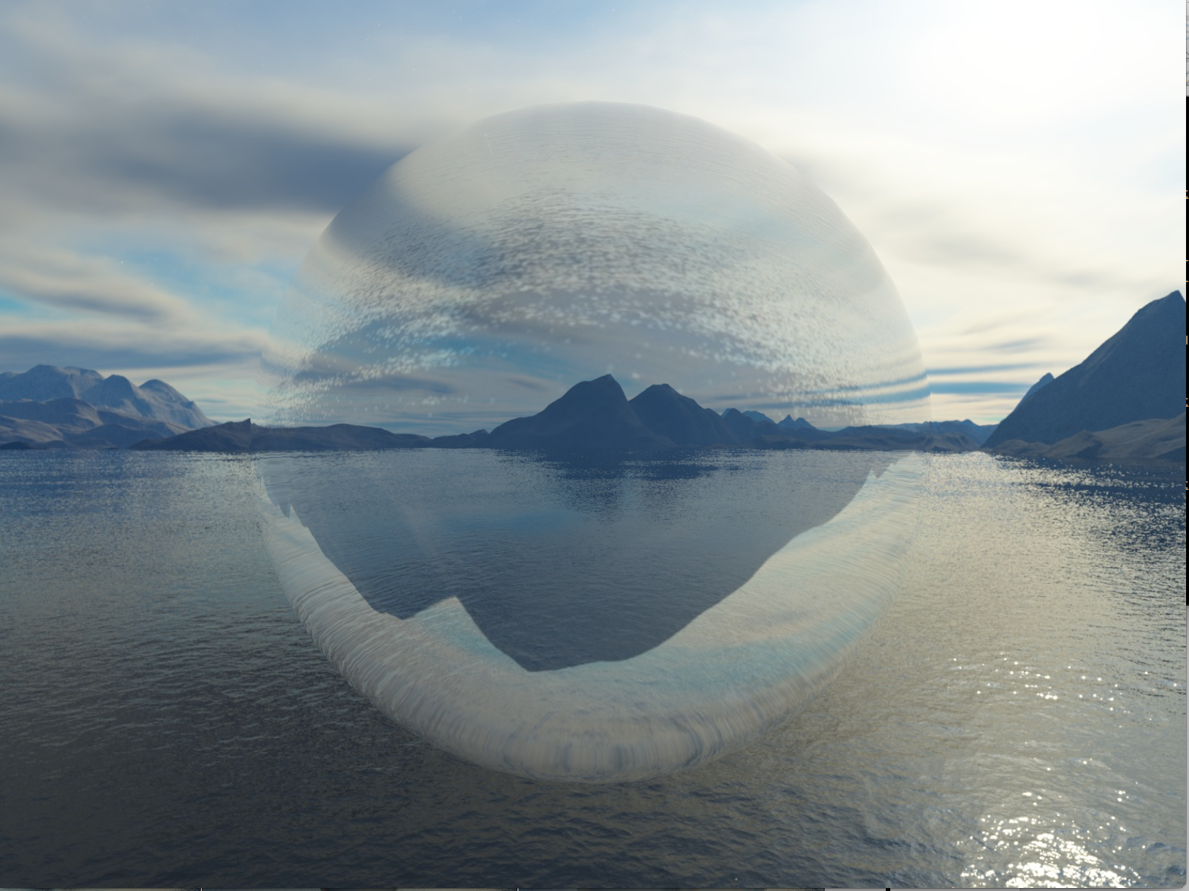



Decreasing distance from camera to globe

(Fresnel reflection, no chromatic aberration)

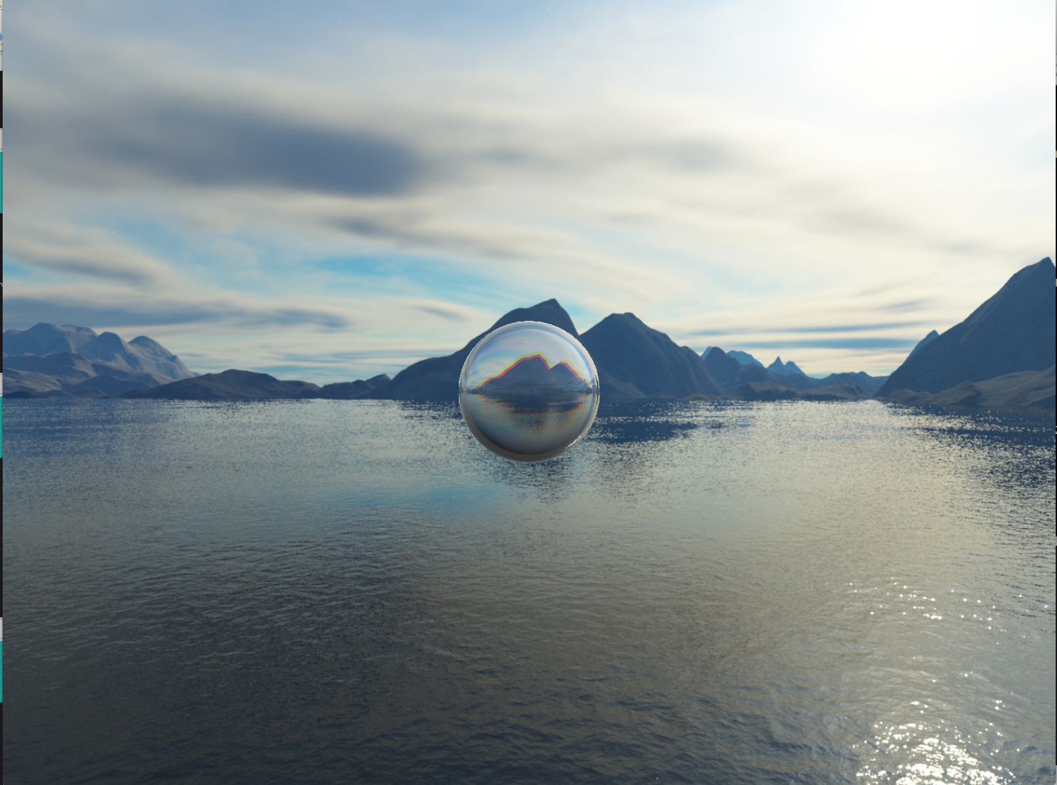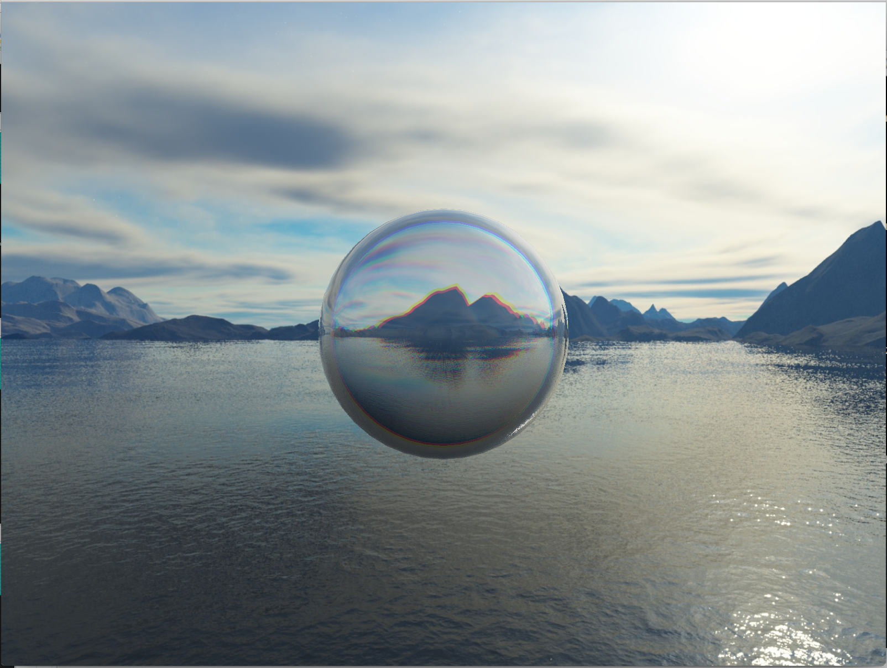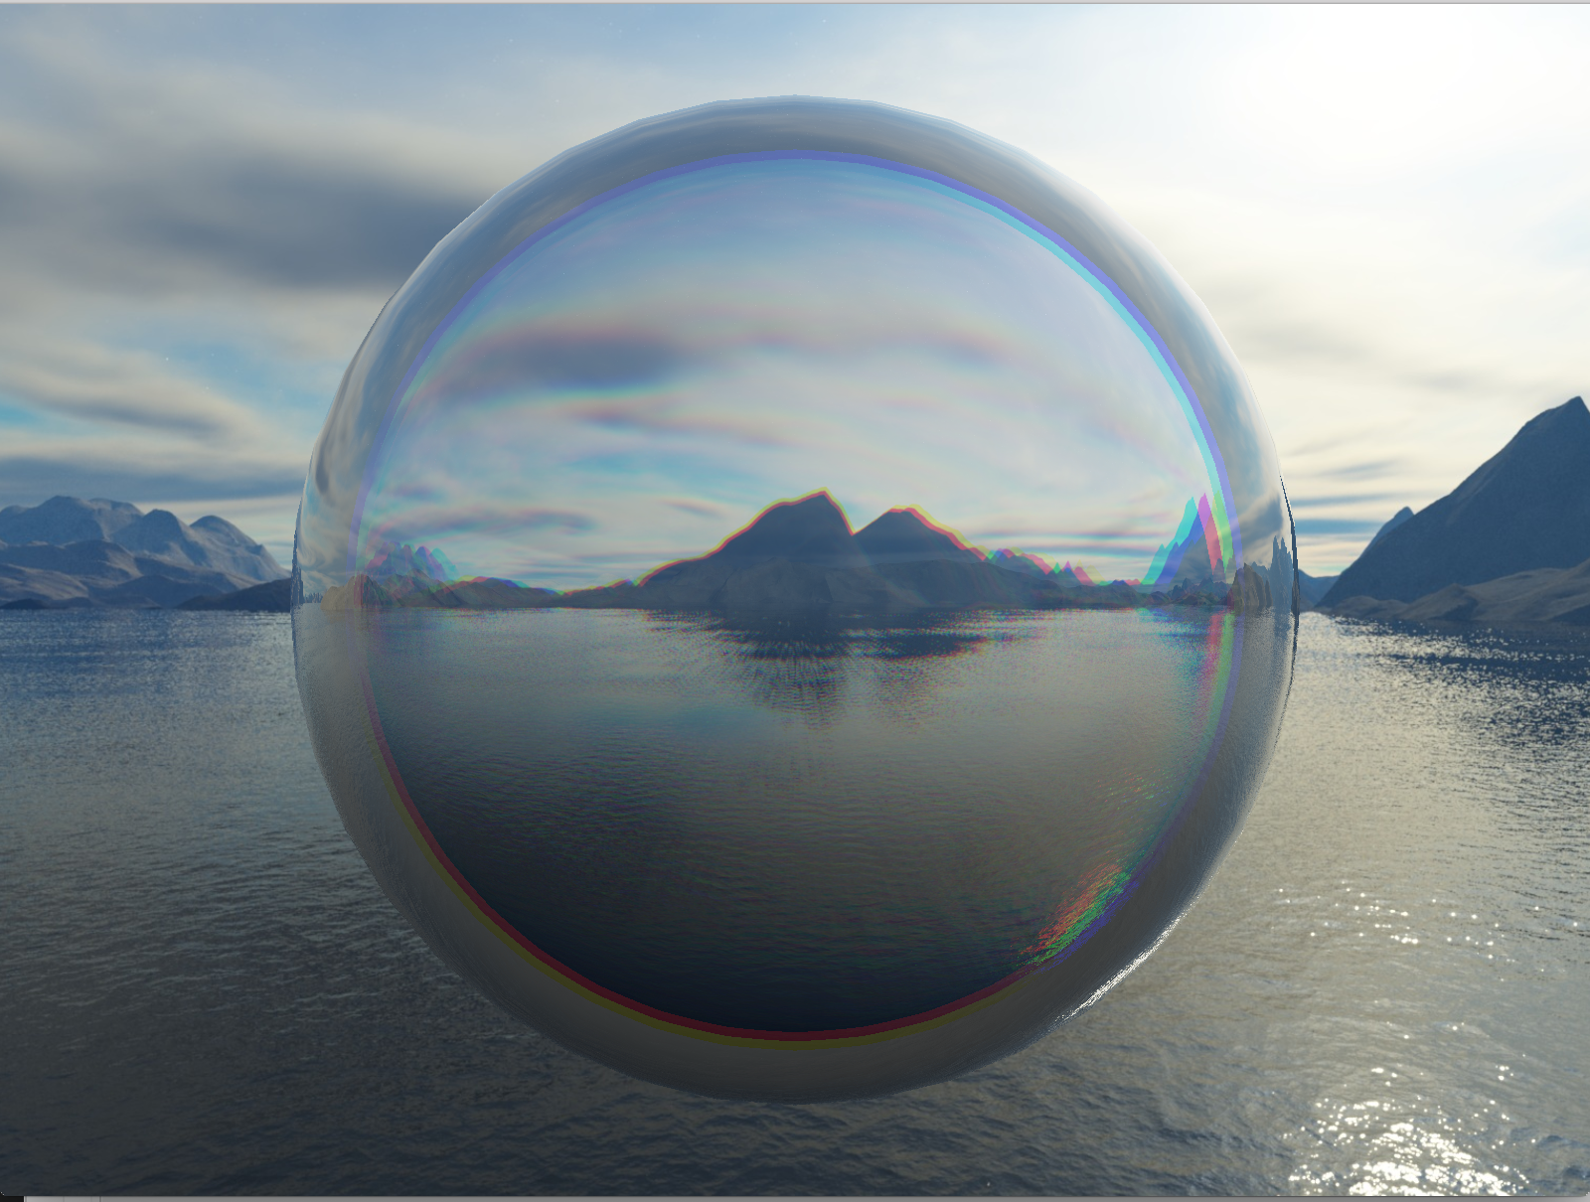



Decreasing distance from camera to globe

(both Fresnel reflection and chromatic aberration)

pictures 3.c.3

1. Draw snowflake and simulation different mode of movement

(details)

1. Set base

(details)

# Relations to CS 148

# Division of Labor

1. Boyu LIU:
2. Rui YAN:
3. Tianci WANG: Shading glass globe and bunny base.

# Source